**Master Position**

**Makes job search easy and simple**

Notice: all additional files (autoSearchURLs.txt, .bmp and .wav files)

MUST be located in the executable folder (where MasterPosition.exe file is located):

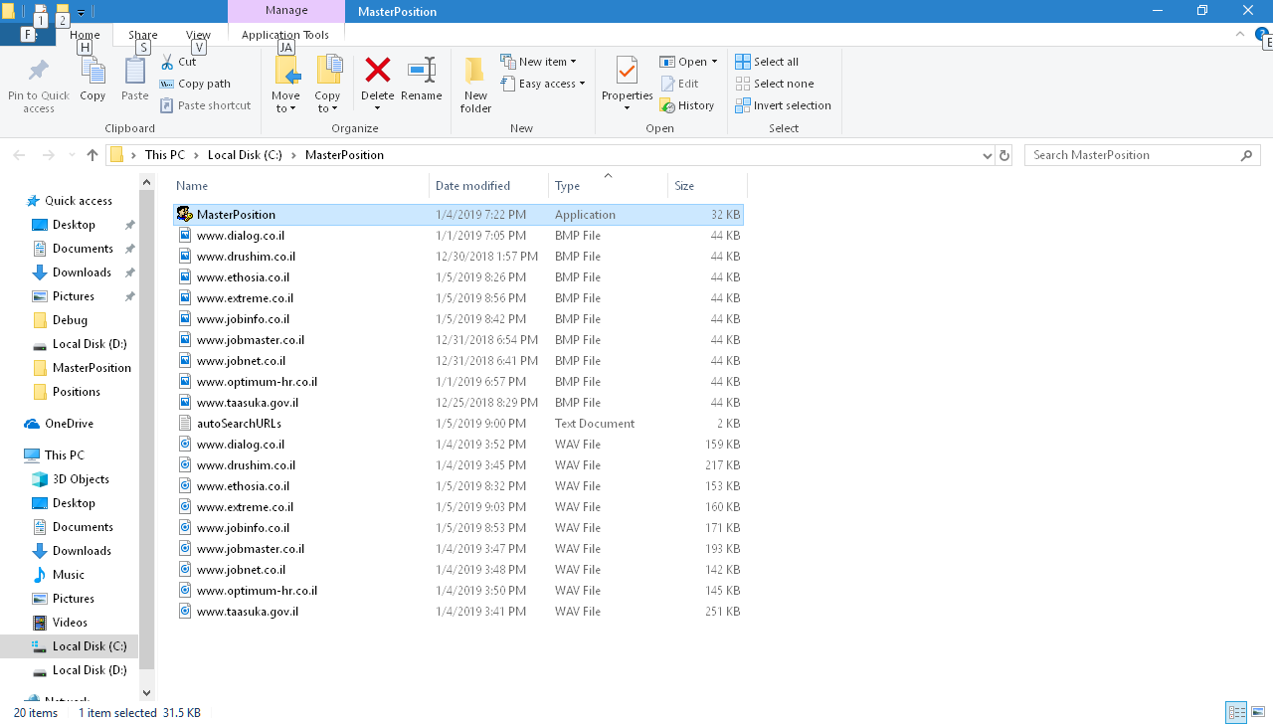

The Main screen of the application looks like that:

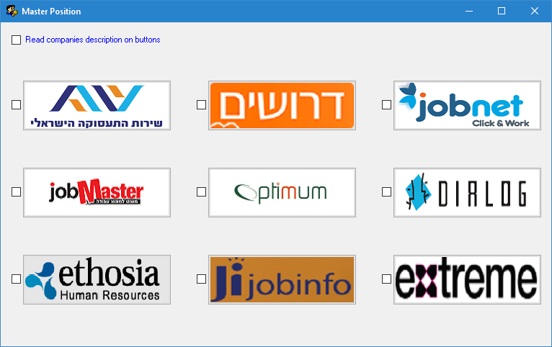

Now, we can:

* Click on a button-> goes directly to the main page of the jobs site
* Check ON the Auto Search checkbox, on the left of a jobs site,

then click on the corresponding jobs site button-> goes directly to the search results page of the jobs site, according to the predefined search criteria

(this is the actual use of the file *autoSearchURLs.txt*)

* Check ON the "Read companies description on buttons" checkbox,

then hover the mouse over a jobs site button-> the jobs site name will be read aloud.

* Resize the window-> the buttons will be arranged accordingly:

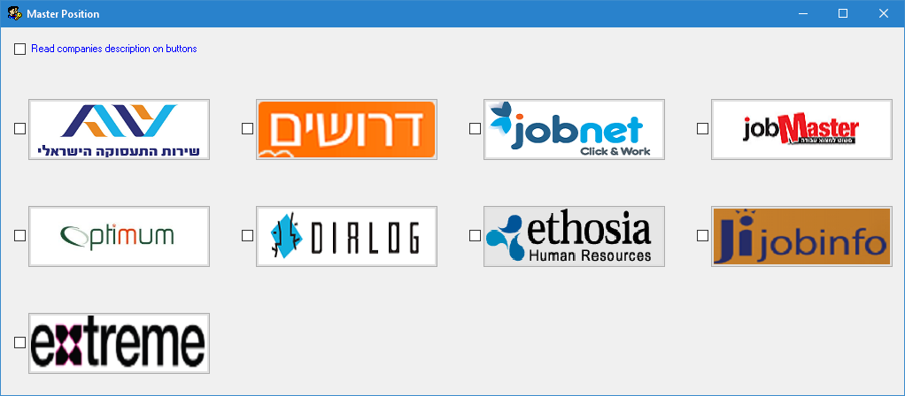

**Code location:** <https://github.com/LiorBob/MasterPosition/blob/master/MasterPosition/frmMasterPosition.cs>

**YouTube demo:**

<https://www.youtube.com/watch?v=TG51E36PkXw>